AP Calc WS#3 Intro to Limit Name: _________________

The main idea in calculus is that of finding a desired quantity by pushing to the limit the process of taking ever better **approximations**.

In the implementation, a real number x gives rise to an approximation f(x) and the process of taking ever better approximations is the process of letting x **get ever closer** to a particular real number a (or possibly ∞). The exact desired quantity is called “the limit of f(x) as x approaches a,” and it is written $\lim_{x→a}{f(x)}$ $\lim_{x→a}{f(x)}$ is the value L that the

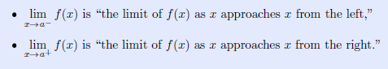 height of the graph approaches

as x gets closer to a **without actuallyequaling a**

Sometimes it happens that the heights approach one value as x gets close to a from the left and a different value as x gets close to a from the right. When this happens, we still say that

$\lim_{x→a}{f(x)}$ does not exist (DNE)

Find the following limit



Use graph to find $\lim_{x→0^{+}}{sin(\frac{2π}{x})}$. Sketch

**Slope of tangent line**: The intuitive notion of a limit given above is enough to allow for a simple example to show the idea behind calculus.

Find the slope of the line tangent to the graph of g(x) = x2 at the point P = (1; 1)

Hint: Use slope formula of two points P and Q (where Q = (x, g(x))

Find the indicate limit by looking at the graph







Find the slope of the line tangent to the graph of g(x) = - x2 + 2x - 1 at the point (2,-1).